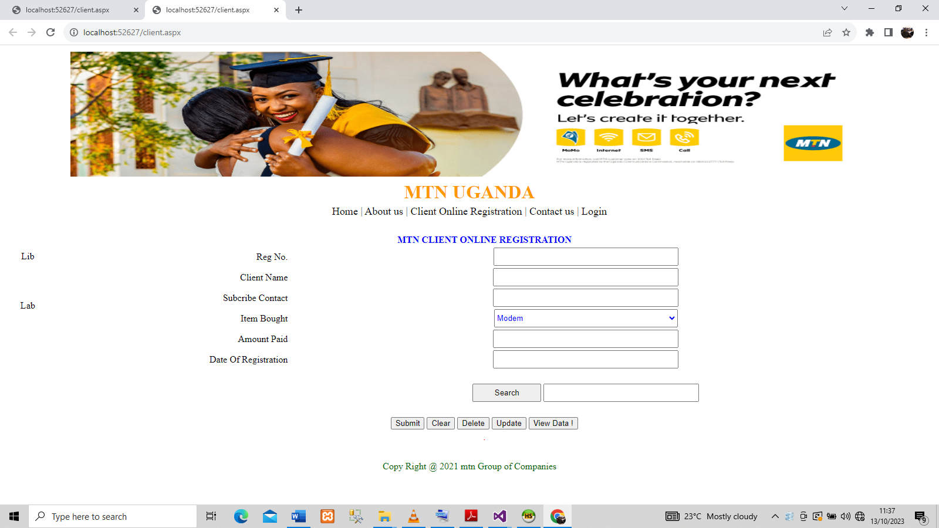
Put a button and ID : searchBtn

Put a Textbox and ID : txt2

//WRITE CODES FOR SEARCH ON THE BUTTON WITH A FUNCTION, COPY THE CODE

protected void searchBtn_Click(object sender, EventArgs e)
{

searchbtn444();
}

private void searchbtn444()
{

MySqlConnection conn2 = new MySqlConnection(@"Data Source=localhost;port=3306;Initial Catalog=mtn;User Id=root;Password=''");

string find = "select * from client where(RegNo like '" + txt2.Text + "' or Name like '" + txt2.Text + "')";

MySqlCommand cmd2 = new MySql.Data.MySqlClient.MySqlCommand(find, conn2);
cmd2.Parameters.Add("@RegNo", SqlDbType.VarChar).Value = txt2.Text;
cmd2.Parameters.Add("@Name", SqlDbType.VarChar).Value = txt2.Text;
cmd2.Parameters.Add("@Contact", SqlDbType.VarChar).Value = txt2.Text;

//conn.Open();
// cmd2.ExecuteNonQuery();

DataTable dt = new DataTable();
MySqlDataAdapter da = new MySqlDataAdapter();
da.SelectCommand = cmd2;
DataSet ds = new DataSet();
da.Fill(ds, "RegNo");
da.Fill(ds, "LastName");
da.Fill(ds, "Contact");
GridView1.DataSource = ds;
GridView1.DataBind();
//conn.Close();

}

